# Lab 4: Platform as a Service Mulligan – Digital Ocean

## Microservices and Cloud Computing - CSC 5201 301

### Hudson Arney

### 23 September 2024

Snapshot of your app running locally.

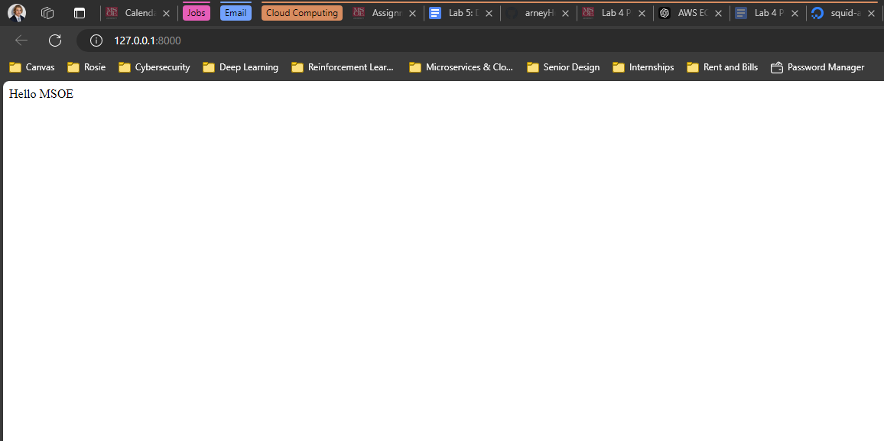

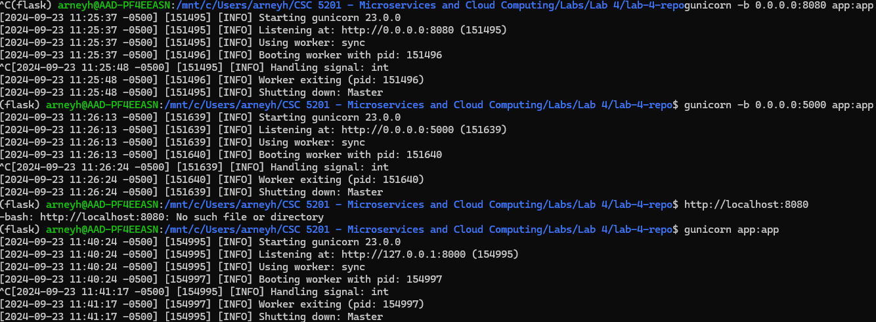

Not sure why I couldn’t run with gunicorn -c gunicorn_config.py app:app   
I tried debugging this for awhile but always got stuck. I’m assuming it has something to do with me being in WSL. I’d like to know what the issue is.   
  
It worked with gunicorn app:app

Snapshot of your DigitalOcean application dashboard showing your app.

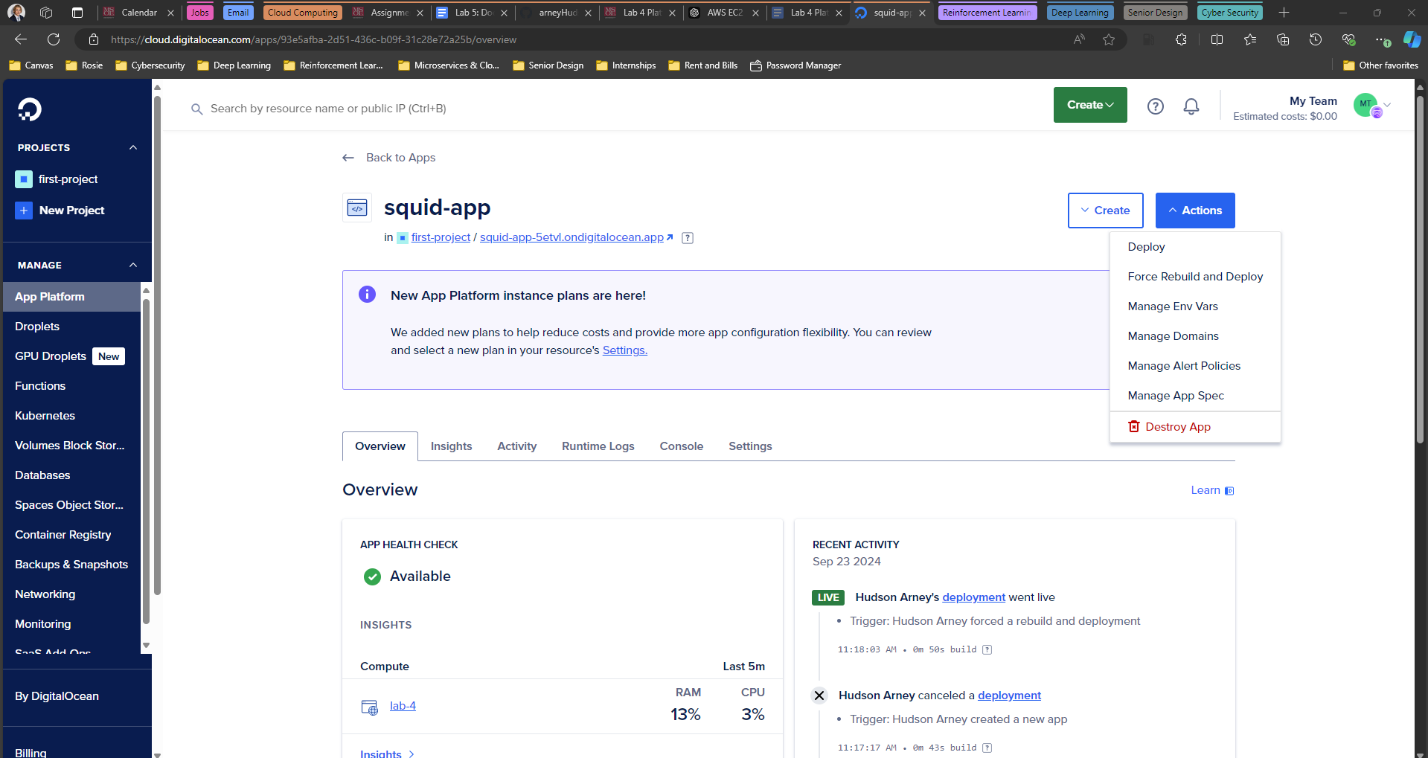

Snapshot of your initial DigitalOcean app running.

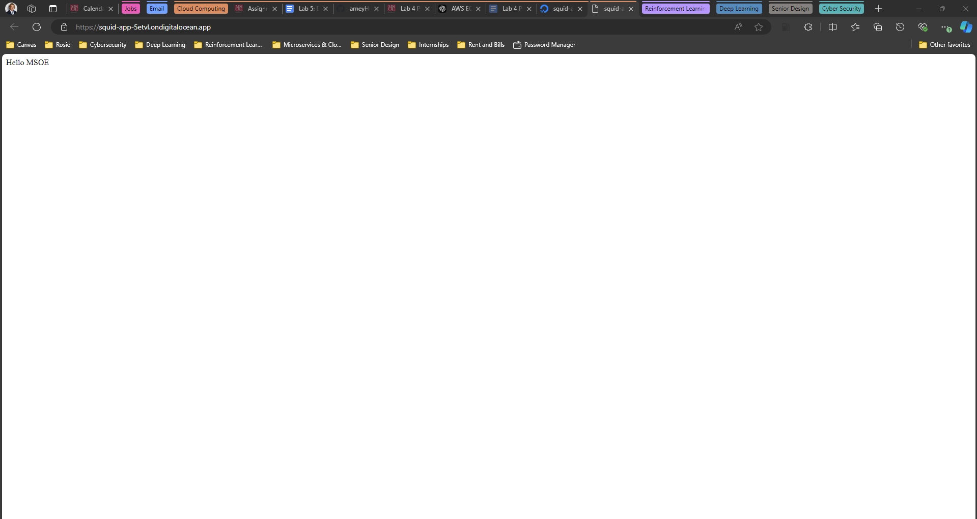

Snapshot of your enhanced app running.



Sorry for the low quality video. I converted the MP4 to a GIF.

**Post Lab Thoughts:** I’ve been having a lot of fun with these labs by adding a little more personality to them. By getting started on this portfolio website now, I hope to have a really nice one by the time I’m done with this class. I liked how easy Digital Ocean was to use with you Git Repo. Being able to simply push your changes and rebuild is nice.

**Challenges/Feedback**: I already sent a message on this but a warning for the pricing would’ve been nice. Instructions were pretty straightforward, and I didn’t have too many issues.